Shortcut commands for git

---------------------------

shortcut for git commands with syntax

git local

1. Install the git client in windows

2.creating the local repoistry

C:\mygitrepo

3.patching the C:\mygitrepo with git bash commands

4.creating the directory---mymavenproject

git init mymavengitproject/

creates .git inside mymavengitproject/

ls .git

copy the test.java to mymavengitproject/

5. git status --display unstached code----test.java

6.git add . -----to commit to staging

7. test.java---committed

8. git diff ( try without commit to check the status)

9.git log

10. git config --global user.name "devopscloudtraining"

11.git config --global user.email onlinetrainingtoindia@gmail.com

12. git config --list

----------

github

git config --global user.name "devopscloudtraining"

git config --global user.email onlinetrainingtoindia@gmail.com

create a empty repoistry in github then clone

git clone git@github.com:devopscloudtraining/javarepo1.git

/javarepo1 in local machines

copy the src codes

git status git add . git status

to push to remote

git remote add origin git@github.com:devopscloudtraining/javarepo1.git

git push -u origin master

Enter passphrase for key '/c/Users/middleware/.ssh/id_rsa':

Counting objects: 3, done.

Compressing objects: 100% (3/3), done.

Writing objects: 100% (3/3), 392 bytes | 0 bytes/s, done.

Total 3 (delta 0), reused 0 (delta 0)

To github.com:devopscloudtraining/javarepo1.git

713bd9b..a1c1a8f master -> master

Branch master set up to track remote branch master from origin.

------------

for pairing with keygen

ssh-keygen -t rsa -C "onlinetrainingtoindia@gmail.com"

remove the known_host file

copy the key info on id_rsa.pub file and add the key to github---->setting--->ssh

host will added

-------------------

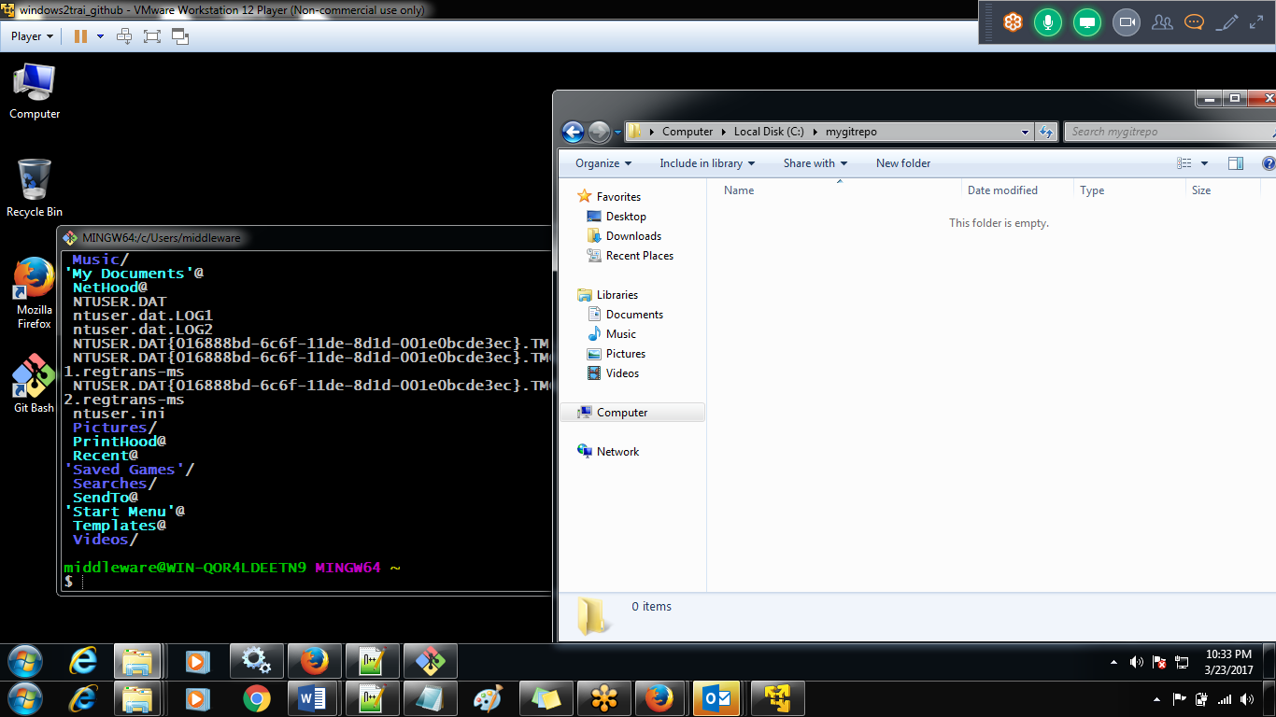

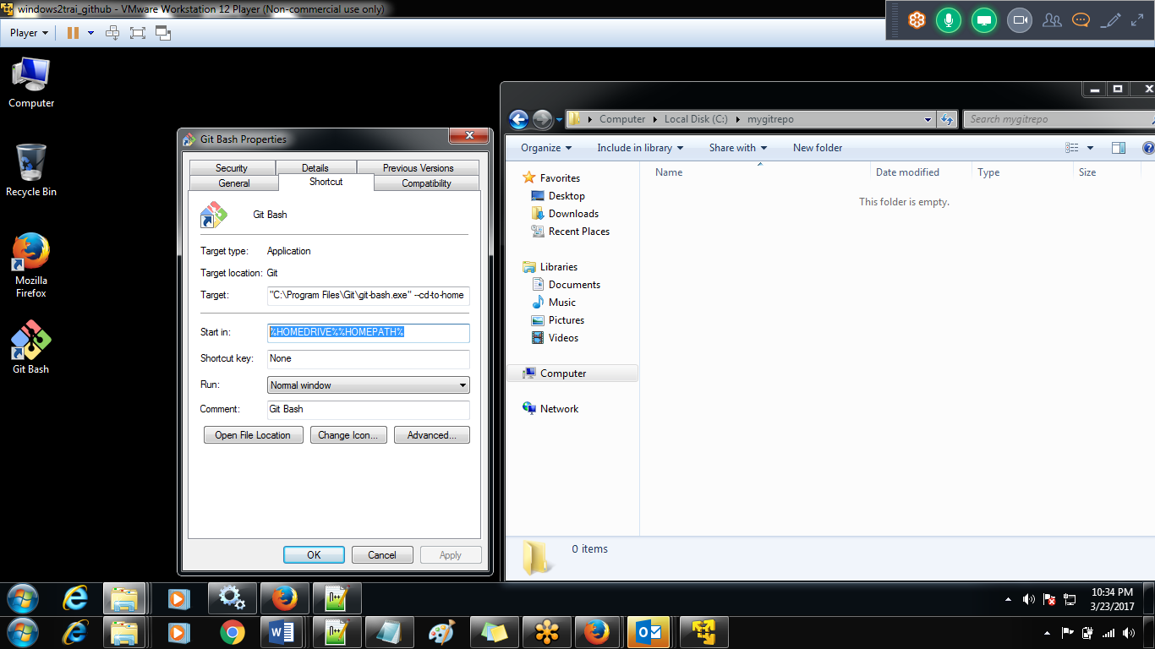

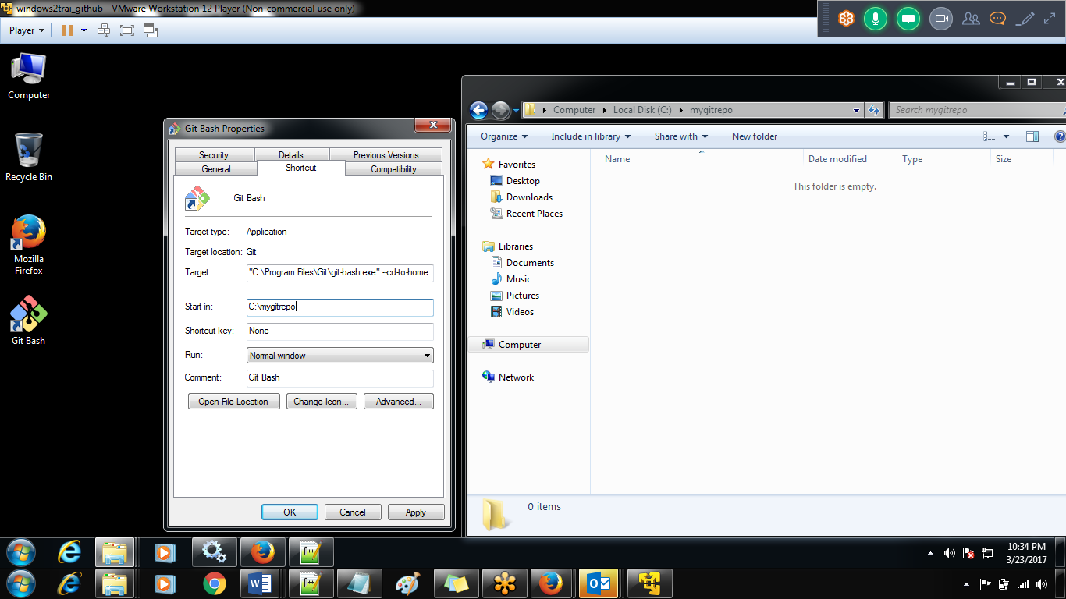

Remove cdtohome

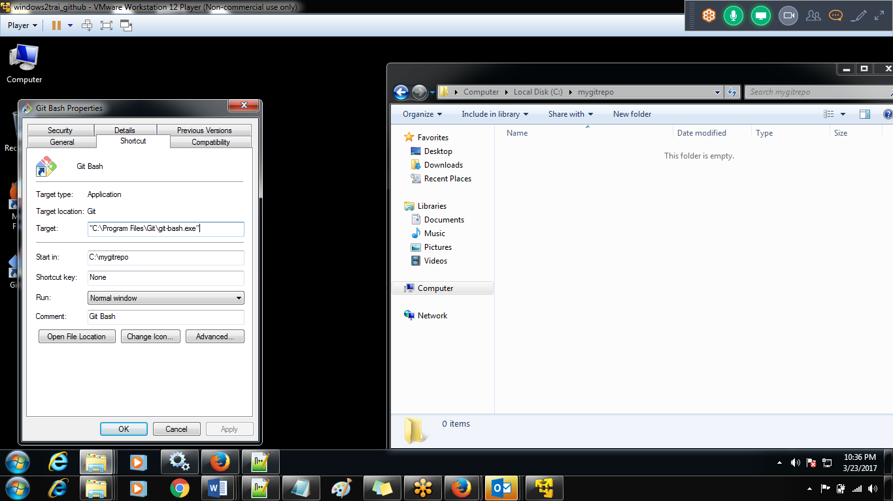

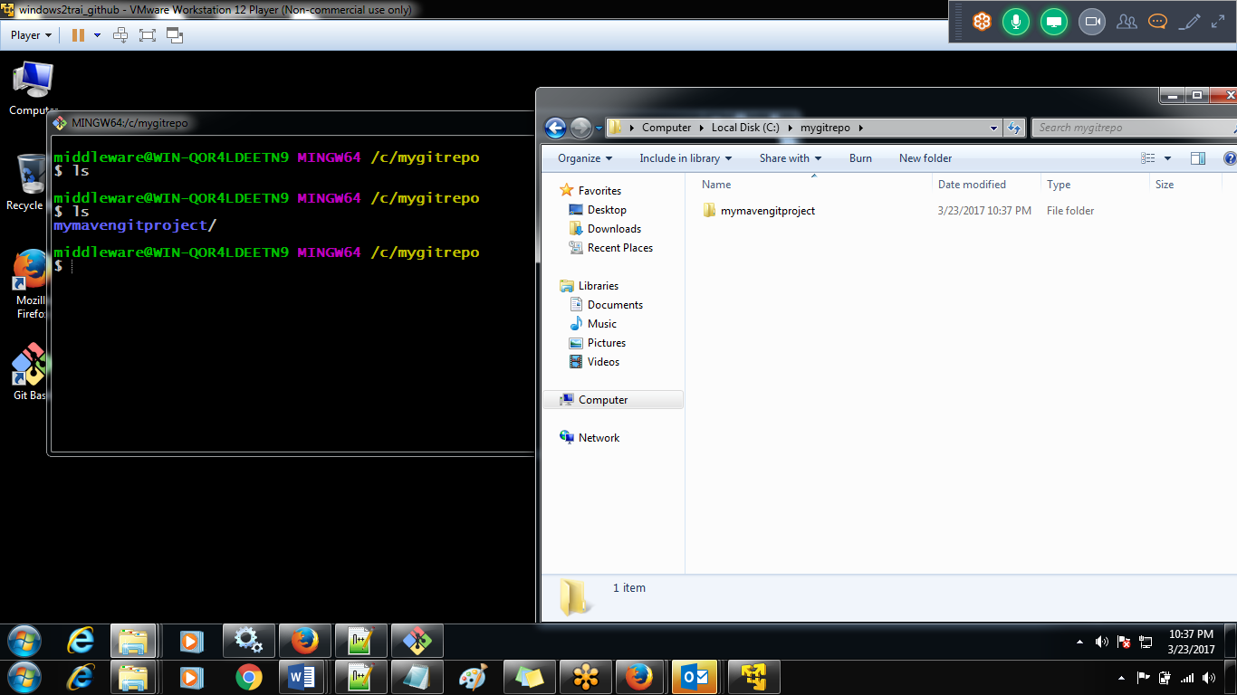

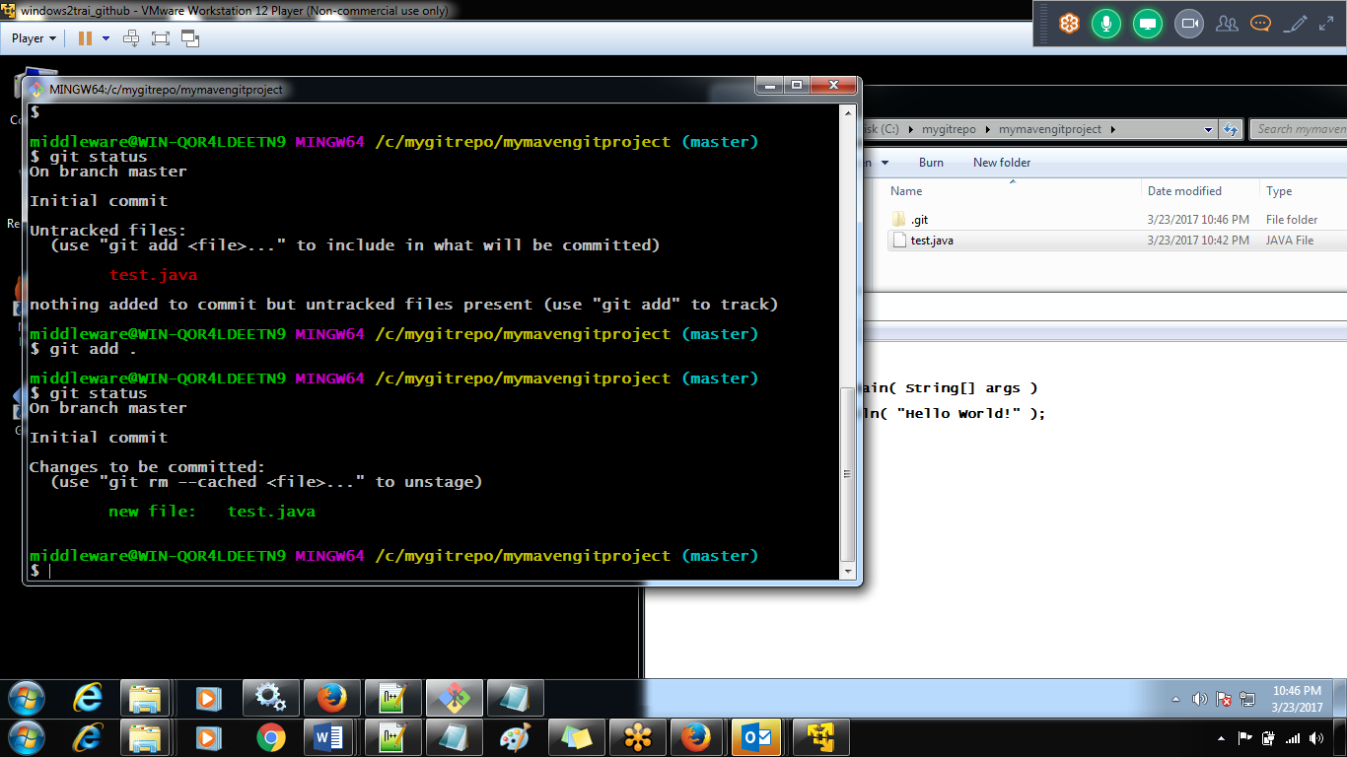

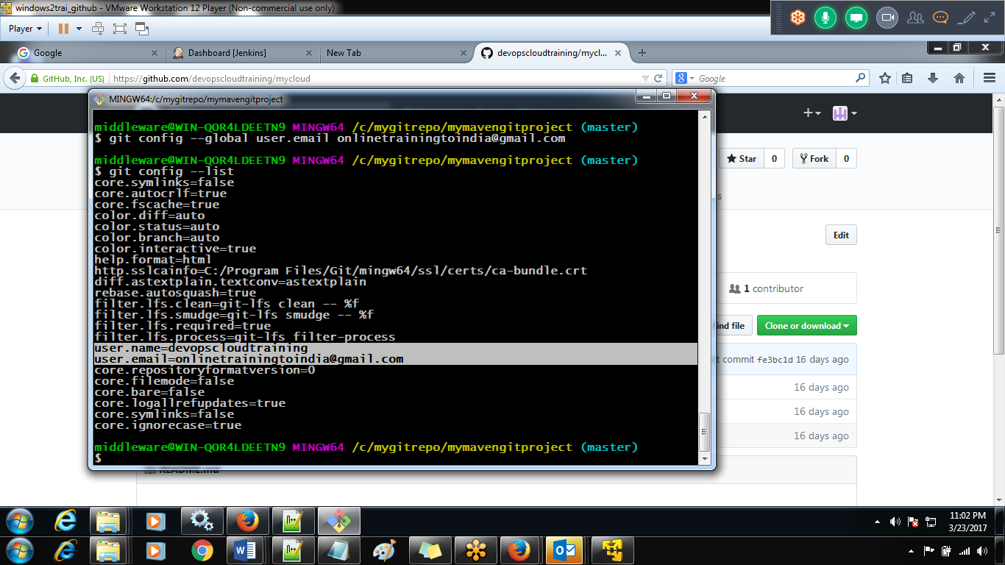

Create the respoistru

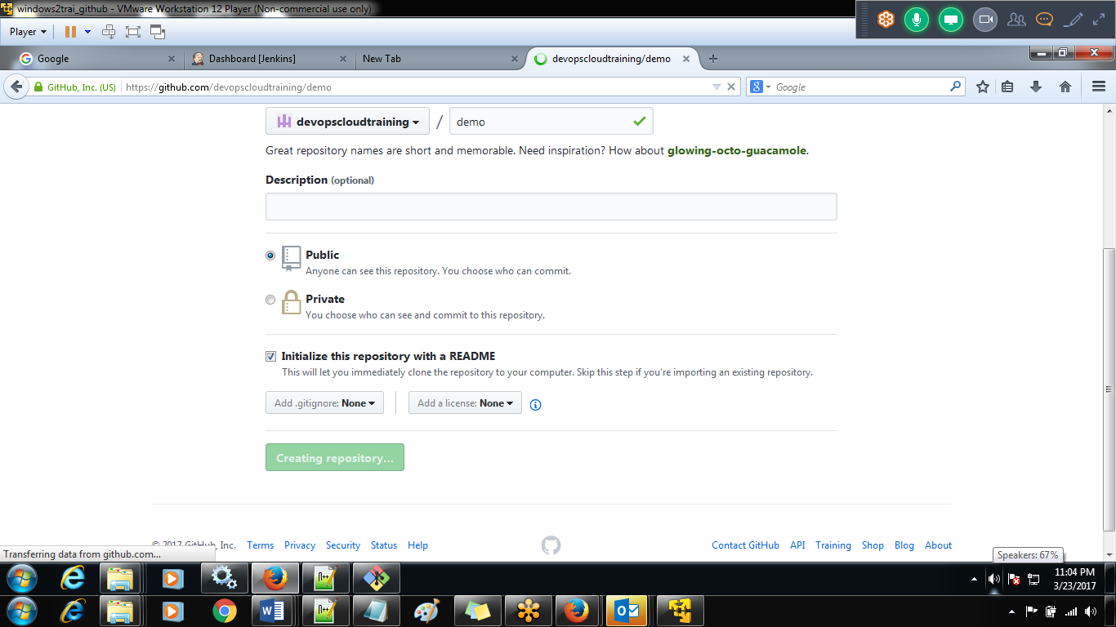

For ssh integration to github

git clone [git@github.com:devopscloudtraining/demo.git](mailto:git@github.com:devopscloudtraining/demo.git)

ssh-keygen -t rsa -C [onlinetrainingtoindia@gmail.com](mailto:onlinetrainingtoindia@gmail.com)

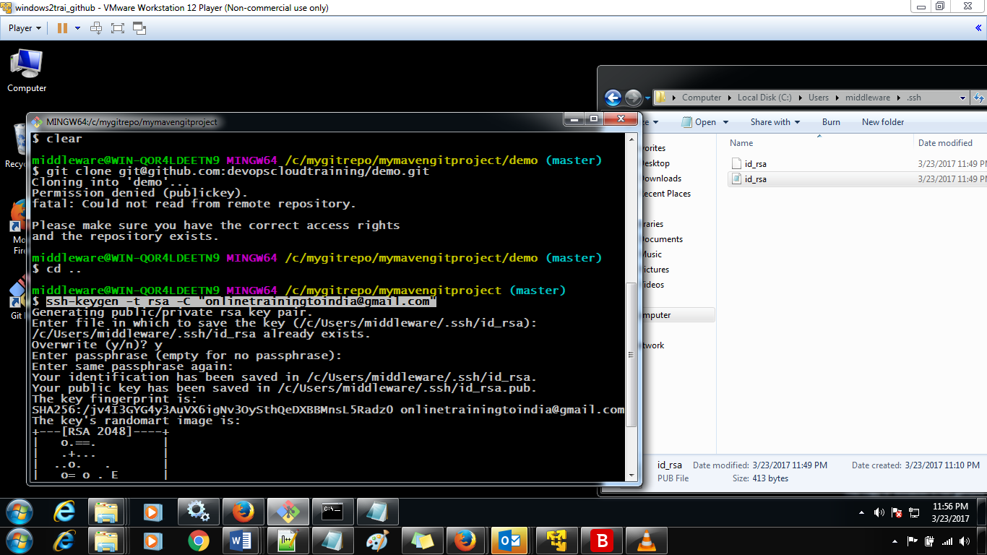

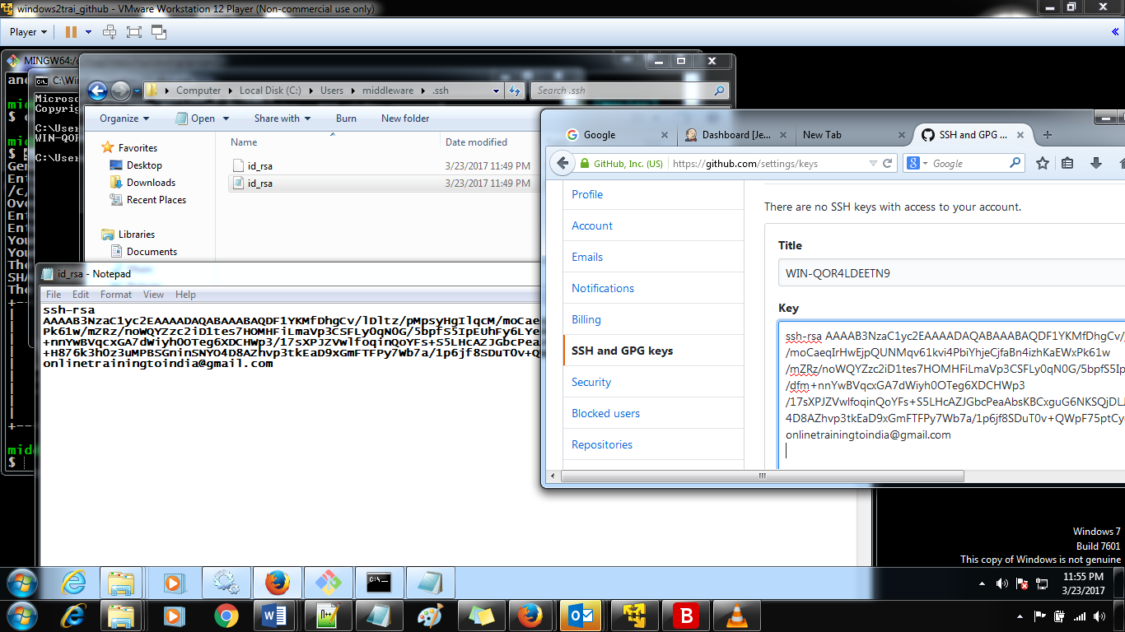

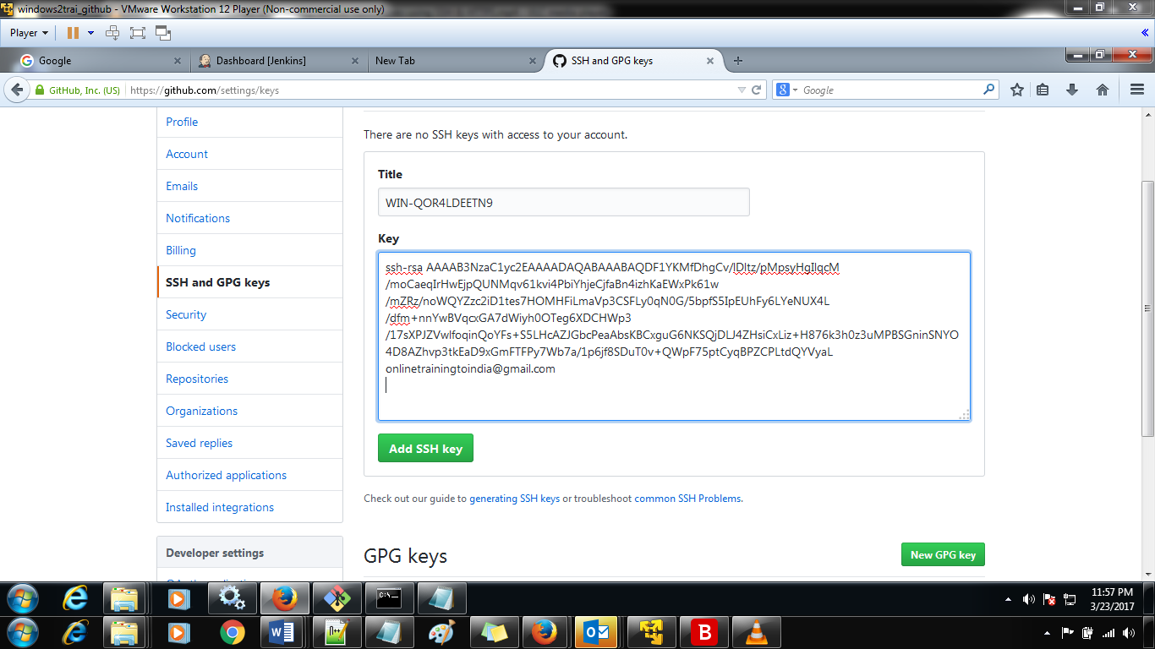

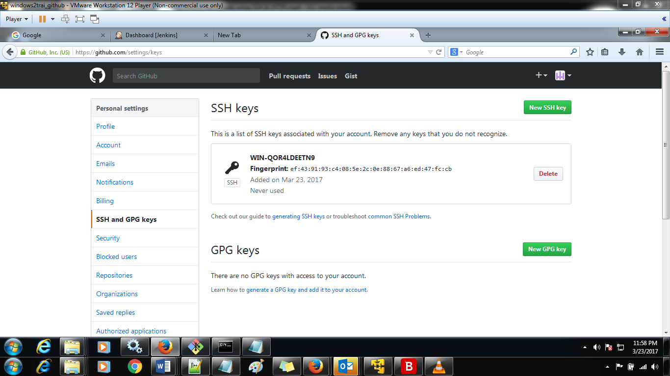

To clone the github demo to local machine

git clone [git@github.com:devopscloudtraining/demo.git](mailto:git@github.com:devopscloudtraining/demo.git)

it will be done

after adding the

git remote add origin git@github.com:devopscloudtraining/demo.git